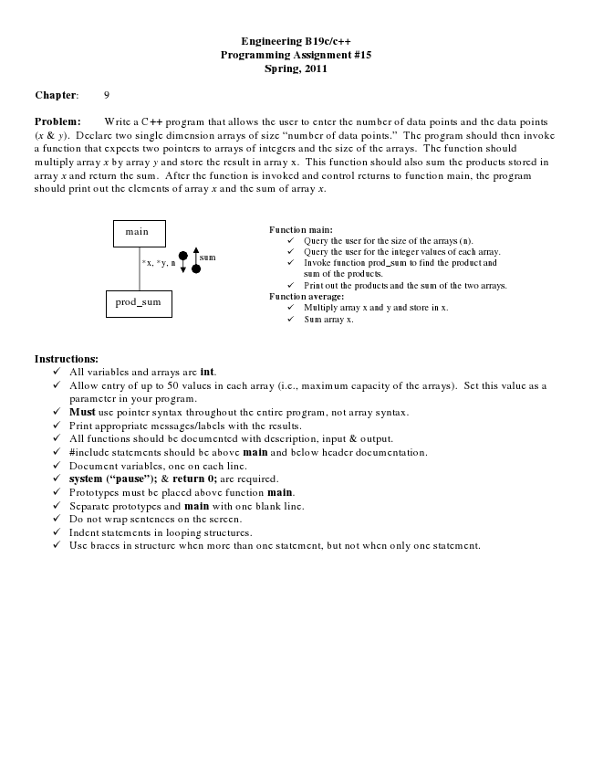

**Engineering B19c/c++ Programming Assignment #15 Spring, 2011**

**Chapter: 9**

Problem: Write a C++ program that allows the user to enter the number of data points and the data points (x & y). Declare two single dimension arrays of size “number of data points.” The program should then invoke a function that expects two pointers to arrays of integers and the size of the arrays. The function should multiply array x by array y and store the result in array x. This function should also sum the products stored in array x and return the sum. After the function is invoked and control returns to function main, the program should print out the elements of array x and the sum of array x.

main

**Function main:**

✓ Query the user for the size of the arrays (n).

*x, *y, n

sum

✓ Query the user for the integer values of each array. ✓ Invoke function prod_sum to find the product and

sum of the products. ✓ Print out the products and the sum of the two arrays. prod_sum

**Function average:**

✓ Multiply array x and y and store in x. ✓ Sum array x.

**Instructions:**

✓ All variables and arrays are int. ✓ Allow entry of up to 50 values in each array (i.e., maximum capacity of the arrays). Set this value as a

parameter in your program. ✓ Must use pointer syntax throughout the entire program, not array syntax. ✓ Print appropriate messages/labels with the results. ✓ All functions should be documented with description, input & output. ✓ #include statements should be above main and below header documentation. ✓ Document variables, one on each line. ✓ system (“pause”); & return 0; are required. ✓ Prototypes must be placed above function main. ✓ Separate prototypes and main with one blank line. ✓ Do not wrap sentences on the screen. ✓ Indent statements in looping structures. ✓ Use braces in structure when more than one statement, but not when only one statement.